Screenshot when the user lost.

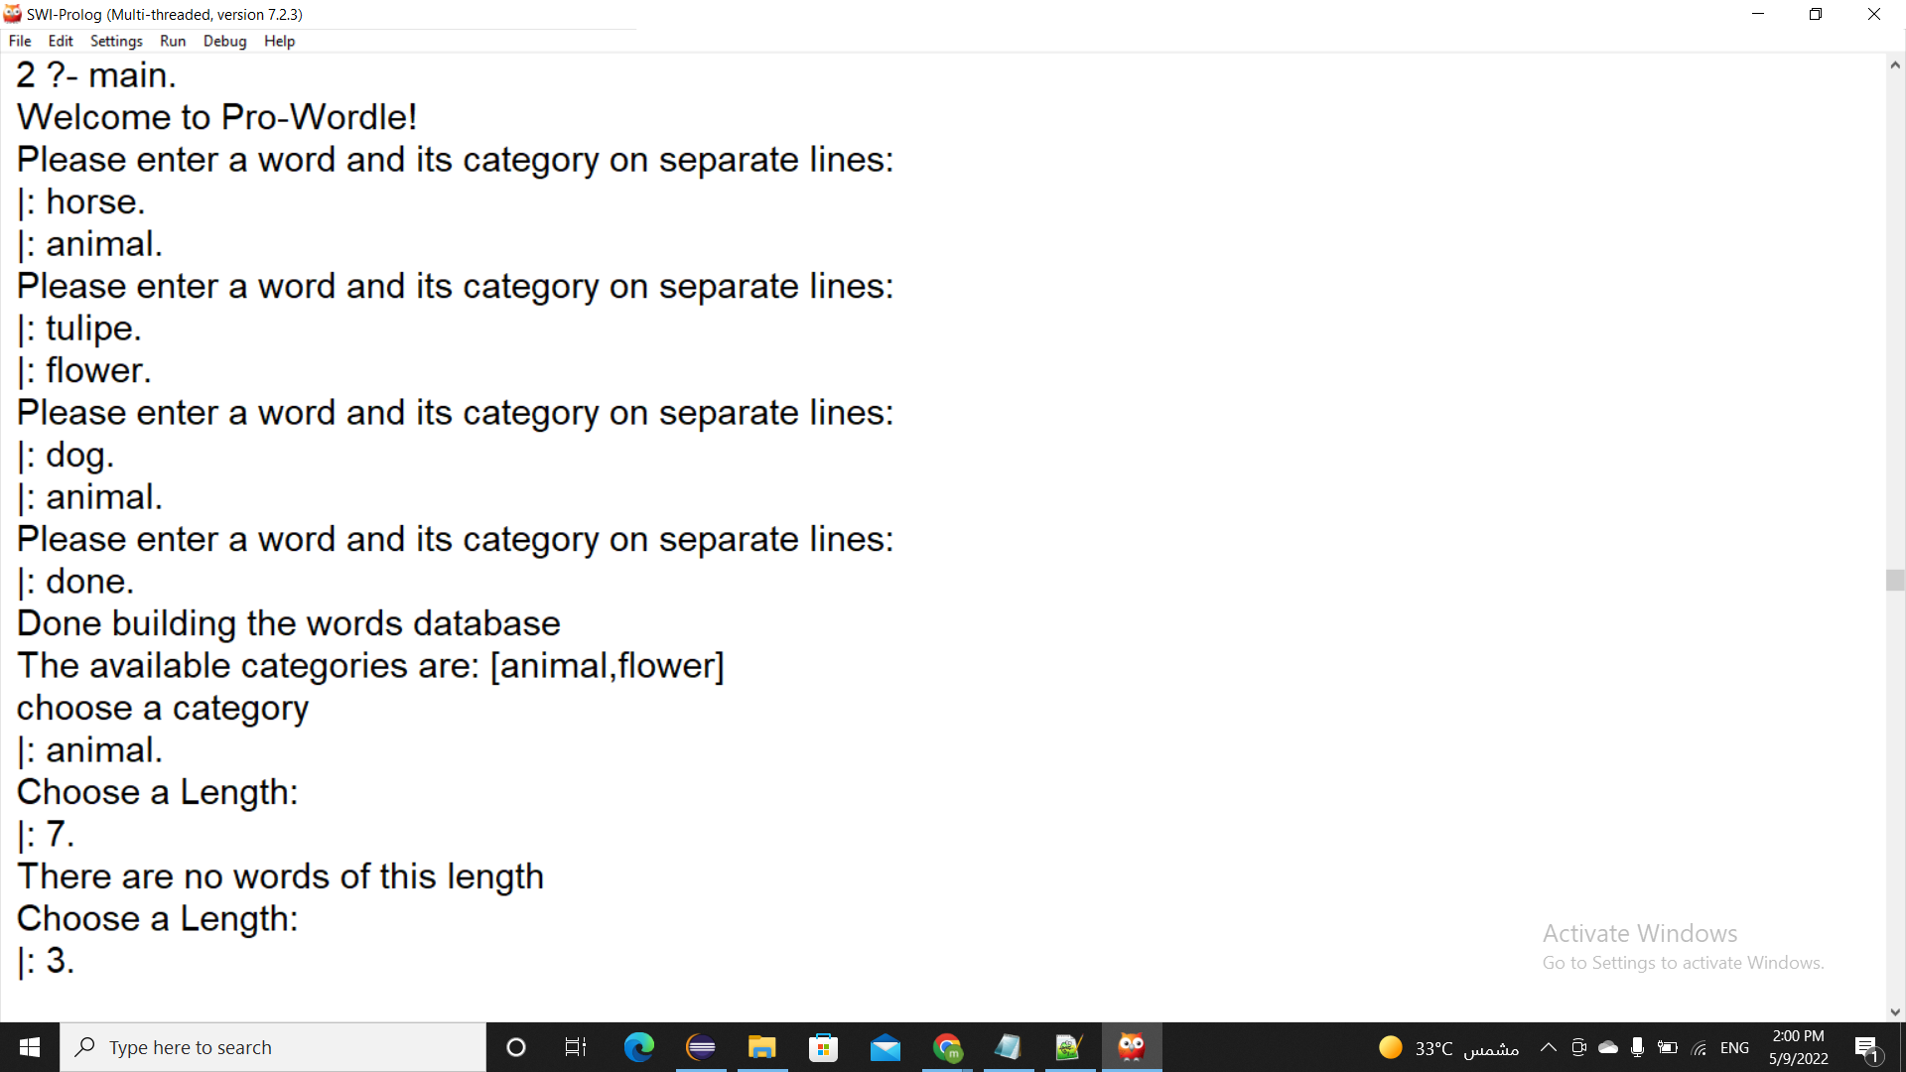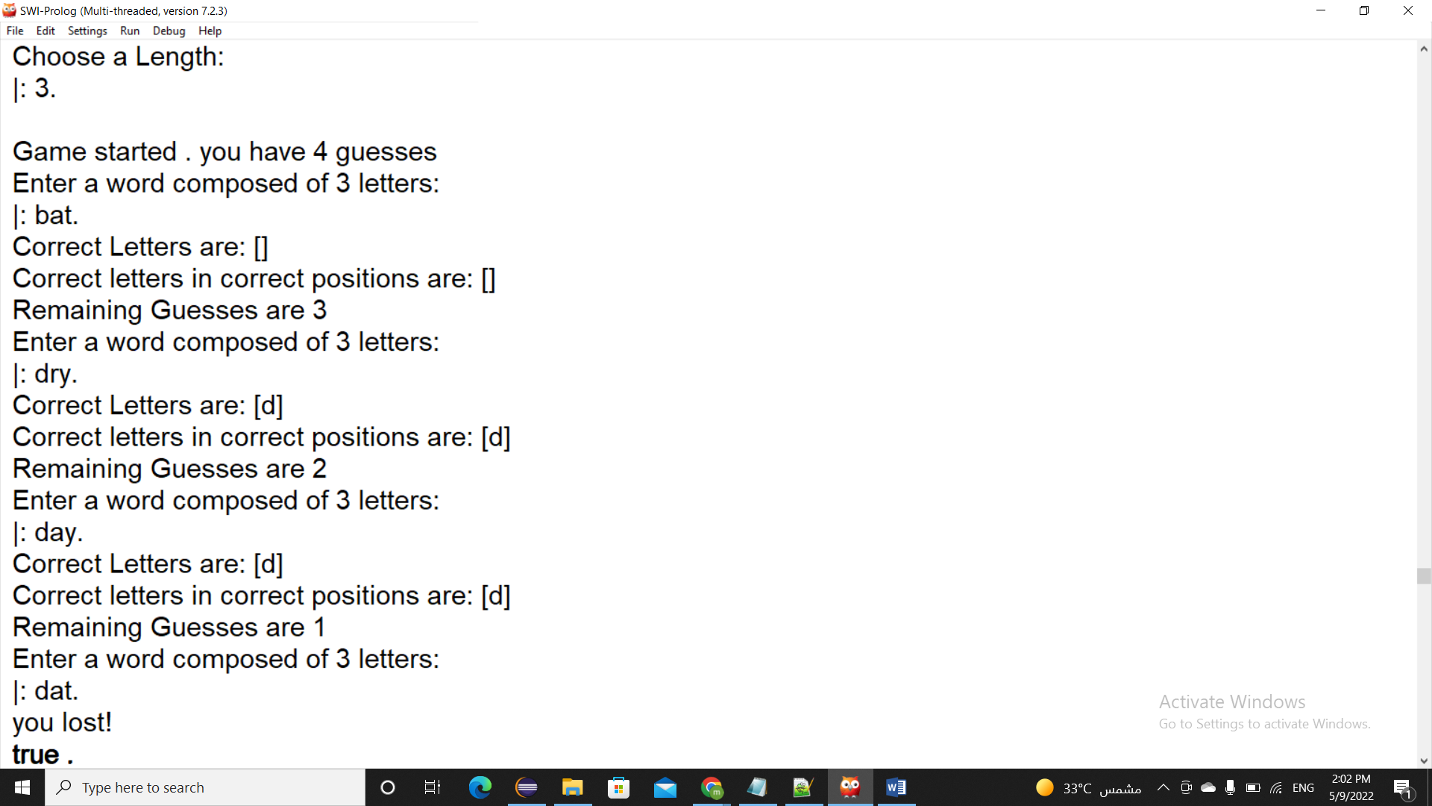

Screenshot when the user win.

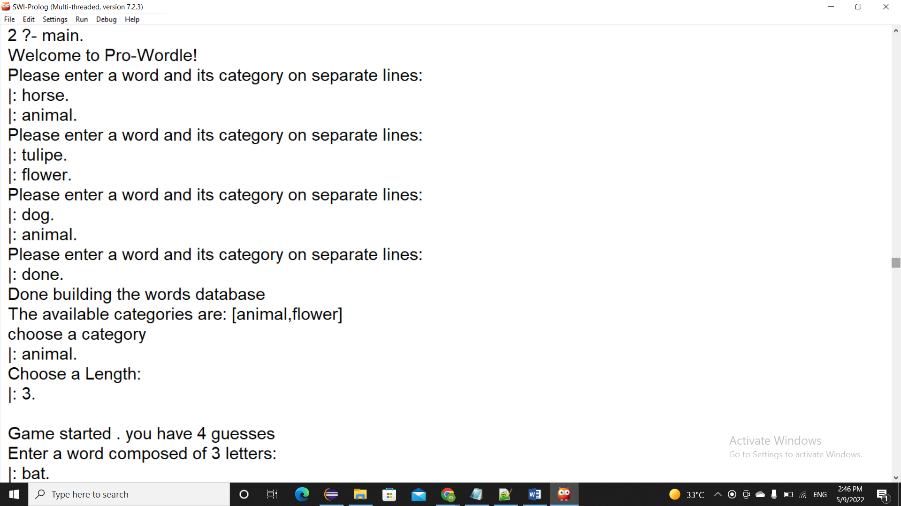

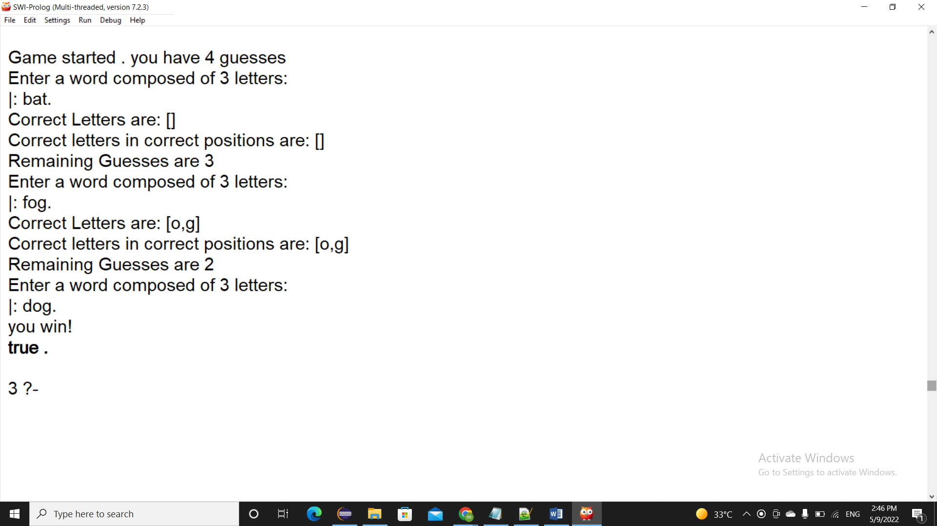

Function of the Predicts:

1) build_kb:

Predict that let the user build the knowledge base.

2) categories(L):

List of all available categories without duplicates.

3) is_category(C):

Get the categories of all available words.

4) available_Length(L):

Get the Length of each word in the KB.

5)pick_word(W,L,C):

Get the word that have length L with category C.

6) correct_letters(L1,L2,L3):

Tell the user the correct letters in L1 and L2 and return it in L3.

7)correct_positions(L1,L2,L3):

Tell the user the correct letters in the correct positions in L1 and L2 and return the answer in L3.

8)takelength(X):

List all the available length in the KB.

9)takecat(G):

Take a category from the user and check whether it in categories(L) or not.

10)checklength(Z,G):  
check whether the input length from the user is in the KB with category G or not .

11)takeword(W,Z):

Take input from the user and checks does the word length is equal to the length that the user iuputed it or not.

12)checkword(W,Count):  
return the correct positions and correct letters in the word inputed by the user by converting them to two lists , and decrement the Count(number of guesses) by 1 when the user enter an input with same length that he inputed above by the user, if the length not equal the Count stays the same, alse it returns to the user if he wins or he lose.

13)play:

It contains the game play phase .

14)main:

It displays the welcome sentence to the user , and calls build_kb (to build knowledge base) and calls play.